Activity 5.4 Calculating Properties of Solids

Introduction
Have you ever stopped to think why it is that you are able to float in water? The reason has to do with the concept of buoyancy. The volume of water that your body displaces has weight. The weight of the displaced water pushes upward on you, while the weight of your body pushes down. If the weight of the displaced water pushing upward is greater than your weight, then you will rise out of the water to a point where equilibrium has been achieved. This means that the weight of your body that is submerged in the water, let’s say from your shoulders down, is equal to the weight of the volume of water that your body is displacing. Another way to explain this is to look at density. If your average weight density, or the average amount of weight per unit volume of your body, is less than the weight density of the water, then you will float. The word average is used because skin, bone, hair, and muscle tissue all have different weight densities. If you were to drop a coin in the water, you would notice that it sinks. The weight density of metal is higher than the weight density of water; therefore, the volume of water that is displaced by the coin cannot weigh as much as the coin itself.

Engineers design vessels to travel on and under the surface of the water. Typically, these vessels are comprised mostly of metal. How is it that these vessels do not sink straight to the bottom of the sea floor? The answer again deals with weight, average density, and volume. If you were to fill a glass with water and place it in a tub full of water, the glass would sink. Like metal, glass has a weight density that is greater than water. If you were to place the same glass in a tub full of water, but with no liquid in the glass, it would float. In this case, the majority of the volume of the space that is taken up by the glass is the air on the inside of the glass, which is significantly less dense than water. Therefore, the average weight density of the glass is less than the weight density of water. This is the reason why ships are able to float. The majority of the volume of a ship is air. This example is only one engineering application of physics and the mathematics associated with the properties of solids.

Equipment
- Engineering notebook
- Pencil

Procedure
In this activity you will learn how to hand calculate the volume, weight, and surface area of common solids. You will then apply your knowledge by calculating these properties for each of your puzzle piece solutions.

- A cast iron cylinder serves as a counterbalance that is used in a window manufacturer’s double-hung window design. The cylinder has a height of 5.25 inches and a diameter of 1.75 inches. The weight density of cast iron is .259 lbs/in.³. Use this information to answer the following questions.

- What is the volume of the cylinder? Precision = 0.00

- What is the surface area of the cylinder? Precision = 0.00

- What is the weight of the cylinder? Precision = 0.00

- If one quart of cleaning solution will clean 7,200 square inches of surface, how many quarts will be required to clean 1,500 cylinders? Round your answer to the nearest quart needed to complete the cleaning.

- What will the total cost be to ship 200 of the cylinders if the shipping rate is $4.25 per pound?

- If a cylinder for a larger window is cut from the same stock (a rod of the same diameter) and must have a weight of 4.25 lb in order for the window to operate properly, how long must the counterweight cylinder be?

- If the original window frame is redesigned such that the space provided for the counterweight requires that the height of the counterweight be reduced to 4.5 in. with the original weight, what is the diameter of the new counterweight design?

- A wood board is one of a dozen different parts in a homemade robot kit. The width, depth, and height dimensions of the board are 3.5 x 17 x 1.5 inches, respectively. The board is made from southern yellow pine, which has an air dry weight density of .021 lbs/in.³.

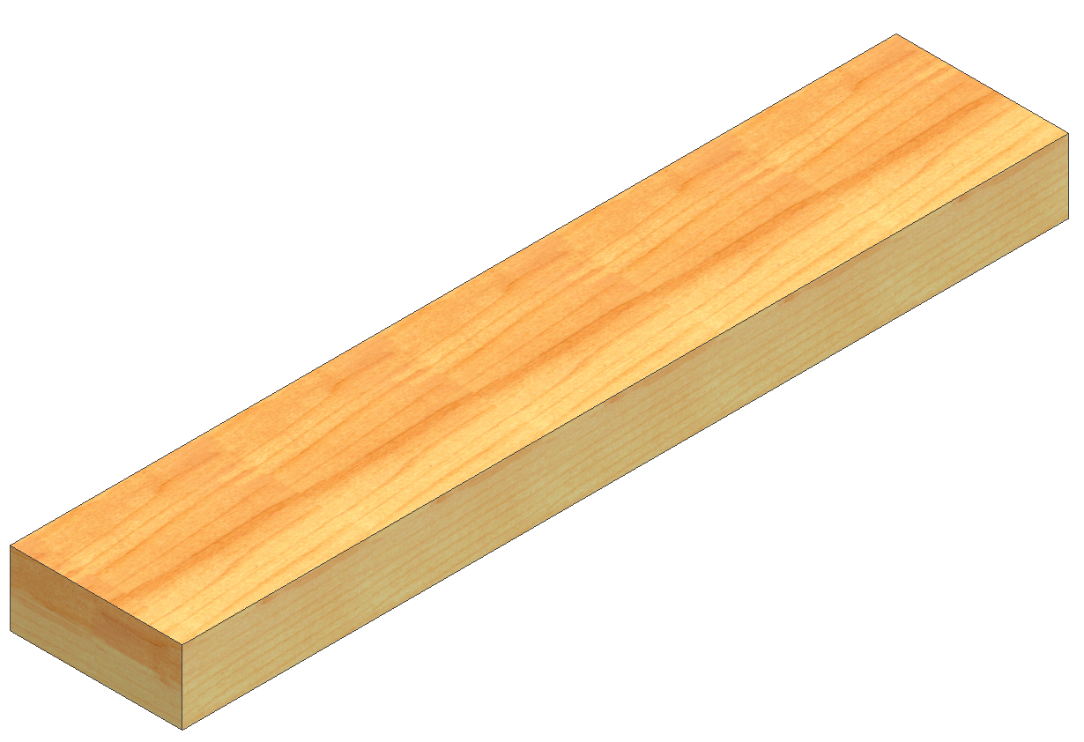

- What is the volume of the wood board? Precision = 0.00

- What is the surface area of the wood board? Precision = 0.00

- What is the weight of the wood board? Precision = 0.00

- If one gallon of paint will cover 57,600 square inches, how many gallons would be needed to give two coats of paint to 25,000 boards? Round your answer to the nearest gallon.

- What will the total cost be to ship the 25,000 boards to a facility for assembling into the finish kit form if the shipping rate is $4.25 per pound?

- If a 2 x 6 (which means the actual dimensions of the board are 1.5 in. x 5.5 in.) milled from the same wood (and therefore has the same density) weighs 3.2 lb, how long is the board?

- (PREVIEW – Optional) Calculate the properties of your puzzle cube pieces.
  - Fill in the following table with the appropriate information. Be sure to use SI units. You may need to re-measure your puzzle pieces using a metric ruler.
Piece identity | Number of cubes | Mass (g) | Surface area (cm²) | Volume (cm³)
- Add Density as the header in the final column of the table. Be sure to indicate appropriate units. Calculate the density for each piece and record the value in the table.
- Create a scatterplot in Excel displaying mass and volume as the variables.
  - Which variable (mass or volume) should you use as the independent variable (which will be plotted on the horizontal axis) in order to best represent the density? Why?

  - Since a zero volume would result in zero mass, to what value should you set the y-intercept?

  - How can you use the trendline of the scatterplot to provide information about the density of the wood? Explain.

- Find a trendline for your mass/volume data. Print a copy of the scatterplot with the trendline and mathematical model displayed.
  - Rewrite the equation of the trendline in function notation such that M(v) = mass and v = volume.

  - What is the slope of the trendline (include units)?

  - How does this compare to your calculated value of density above? Explain any difference.

- Convert the density indicated by the equation of your trendline to weight density in pounds per cubic inch. Show your work including all conversion factors.

- What is the mass of your complete puzzle (in grams)?

- Convert the mass of your complete puzzle to weight in pounds. Show your work.

- Convert the mass of your complete puzzle to weight in ounces. Note that 1 lb = 16 oz. Show your work.

- If WeShipIt offers a flat rate of $7.95 to ship a parcel up to ten pounds (as long as it fits within a 18 cm x 18 cm x 18 cm box), how many cubes can be shipped in this box for $7.95? Be sure to check both the size and the weight constraints. Ignore the weight of the box.

- If the same wood is used to build a CD storage unit according to the drawing below, what is the weight of the shelving unit? All dimensions in the drawing are in inches.

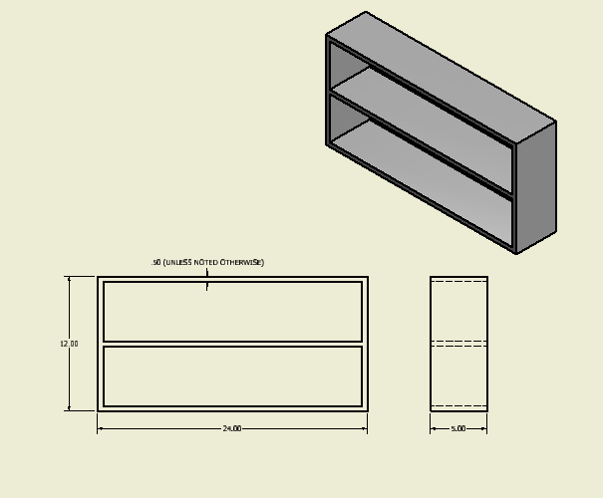
Conclusion
- What is the difference between area and volume?

- What is weight density?

- What is a “physical” property? Give examples of physical properties.

